H.U. MECHANICAL ENGINEERING

GENERAL CHEMISTRY LAB REPORT

SOLUTIONS

GÖKAY KART

KIM-121-6

CANAN ARMUTÇU

Aim

In this experiment, it is aimed how a solution is prepared and how the experimental data will be used.

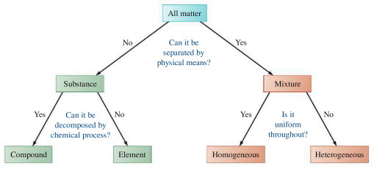

Homogeneous Mixture

A mixture of substances can vary in composition and properties from one sample to another. One that is uniform in composition and properties throughout is said to be a homogeneous mixture or a solution. Ordinary air is a homogeneous mixture of several gases, principally the elements nitrogen and oxygen. Seawater is a solution of the compounds water, sodium chloride (salt), and a host of others. Gasoline is a homogeneous mixture or solution of dozens of compounds.

Heterogeneous Mixtures

In heterogeneous mixtures sand and water, for example the components separate into distinct regions. Thus, the composition and physical properties vary from one part of the mixture to another. Salad dressing, a slab of concrete, and the leaf of a plant are all heterogeneous.

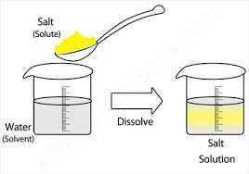

Solution-Solvent-Solute

* Solution is a homogeneous mixture of two or more substances.
* Solute is the substance that is being dissolved, while the solvent is the dissolving medium.
* Solvent is the larger fraction of mixture.

Various Types of Solutions

State of Solution - State of Solute - State of Solvent

Metal alloys solid solid

Salt water solid liquid

Moth balls gas solid

Alcohol in water liquid liquid

Air gas gas

Soda gas solid

Amalgams liquid liquid

Solution Compositions

Molarity (M)

Molarity (M) is defined as the number of moles of solute per liter of solution.

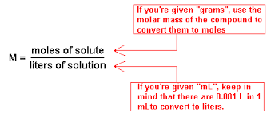

Mass (weight) percent

Mass percent represents the mass of a particular component in a mixture divided by the total mass in the given mixture.

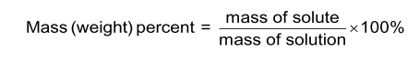

Mole fraction (Xa)

Mole fraction represents the number of molecules of a particular component in a mixture divided by the total number of moles in the given mixture.

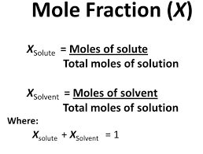

Molality (m)

Molality(m) is defined at the number of moles of solute divided by the number of kilograms of solvent.

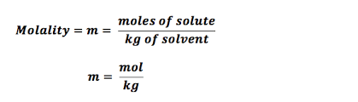

Other Solution Compositions

Volume percent

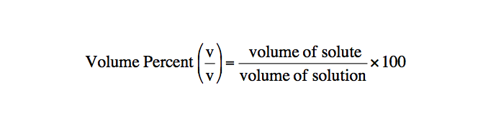

Mass-volume percent

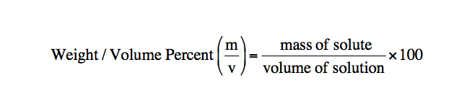

Ppm – Ppb – Ppt

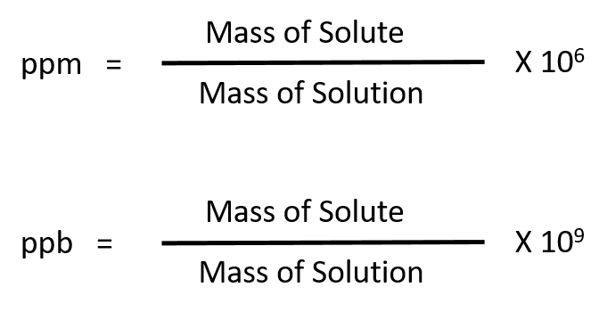

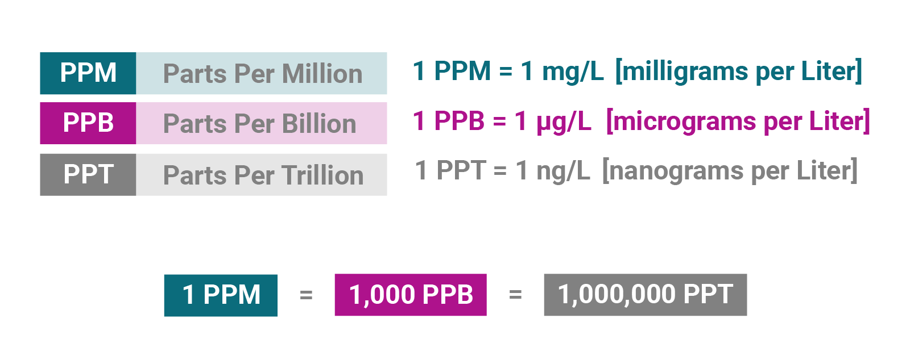

Solubility

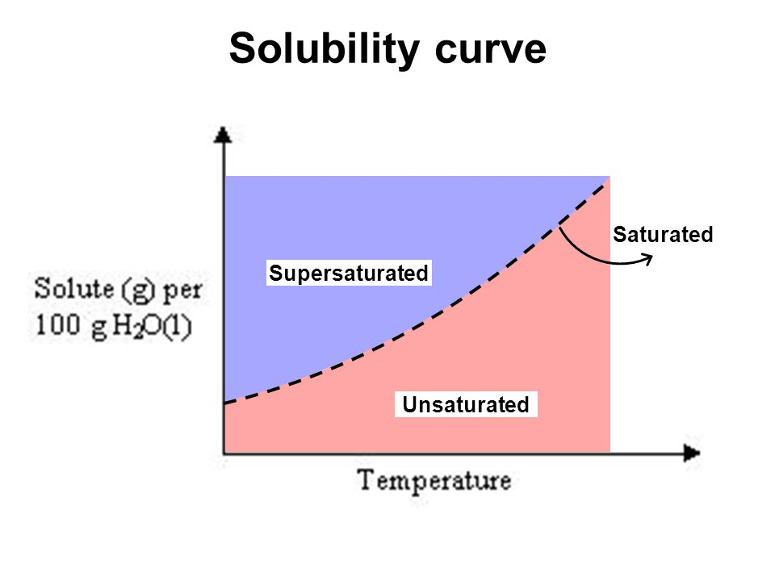

Saturated solution - Unsaturated solution - Supersaturation

A saturated solution is a solution that contains the maximum amount of solute that is capable of being dissolved. An unsaturated solution is a solution that contains less than the maximum amount of solute that is capable of being dissolved. Supersaturation occurs with a chemical solution when the concentration of a solute exceeds the concentration specified by the value equilibrium solubility.

How is Supersaturated solution obtained?

Solubility varies with temperature. If in preparing a solution, we start with less solute than would be present in the saturated solution, the solute completely dissolves, and the solution is an unsaturated solution but suppose we prepare a saturated solution at one temperature and then change the temperature to a value at which the solubility is. The excess solute usually crystallizes from solution but occasionally all the solute may remain in solution. Since the amount of solute is greater than a saturated solution, the solution is said to be a supersaturated solution and the supersaturated solution is unstable.

Discussion part of the experiment;

What should be considered when preparing the solution?

* Glass containers used in solution preparation should be cleaned, passed through pure water and dry.
* It is not possible to prepare a solution of the desired concentration from moisture absorbed and impure substances.
* While preparing the solution of solids, the weighed solid must first be dissolved in a beaker and then transferred to a balloon flask.
* The beaker used should be rinsed with some pure water and this water should be added to the solution.

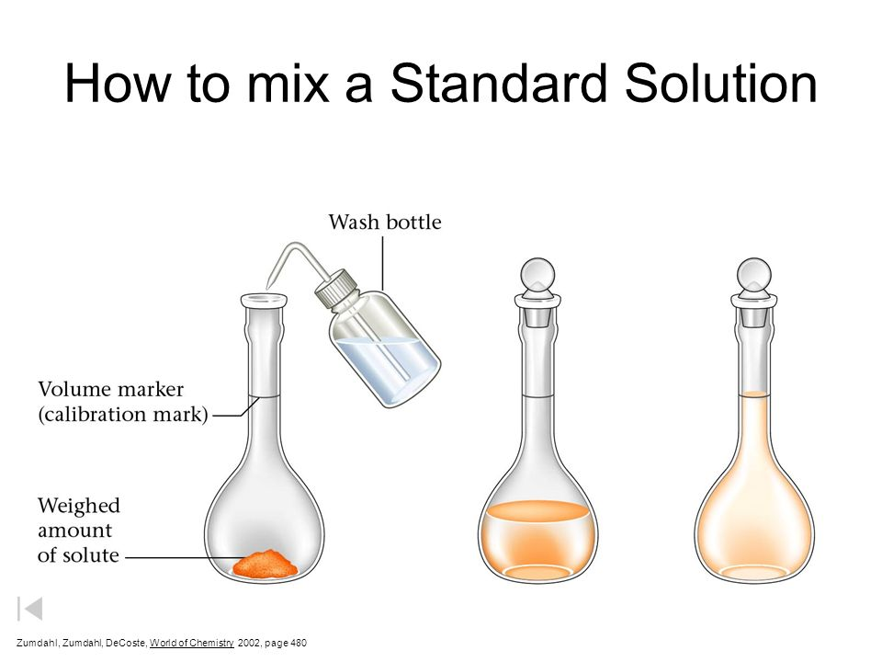

Solution-1(NaCI-H2O)

When preparing a solution with a solvent such as NaCl, some solvent must first be taken in each and mixed together. Then the balloon should be transferred to the flask. It should be shaken with the solvent used also, for the same reason, the mixing stick should be rinsed with solvent (water). Then the meniscus in the balloon flask should be filled up to the line with solvent. Then we need to close the mouth of the balloon flask and turn it upside down a few times. Finally, the solution consisting of solids is ready.

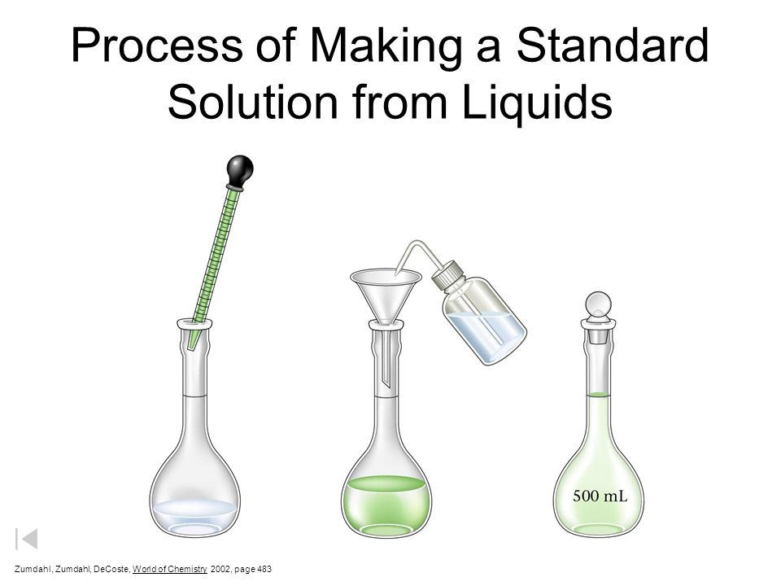

Solution (HCI-H2O)

In solutions consisting of acids such as HCI, some solvent (water) should first be added into the flask, then the desired amount of solute should be added slowly. Then we need to close the mouth of the balloon flask and turn it upside down a few times. Finally, the solution consisting of acids is ready.

What is the meniscus line?

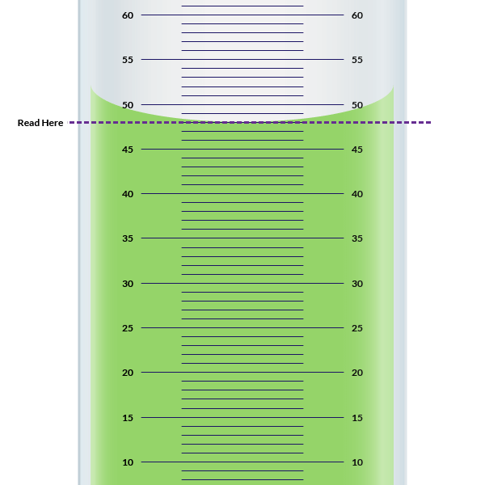

* The curve formed by the surface tension of liquids in a balloon jojo.
* The lower point of the meniscus coincides with the upper point of the grading line.
* It is an international line.
* It is used in calculations in solutions.

Questions & Answers:

1-A) How many grams of concentrated nitric acid solution should be used to prepare 250 ml of 2.00 M HNO3? The concentrated acid is 70.0% HNO3. (Molecular weight : 63g/mol)

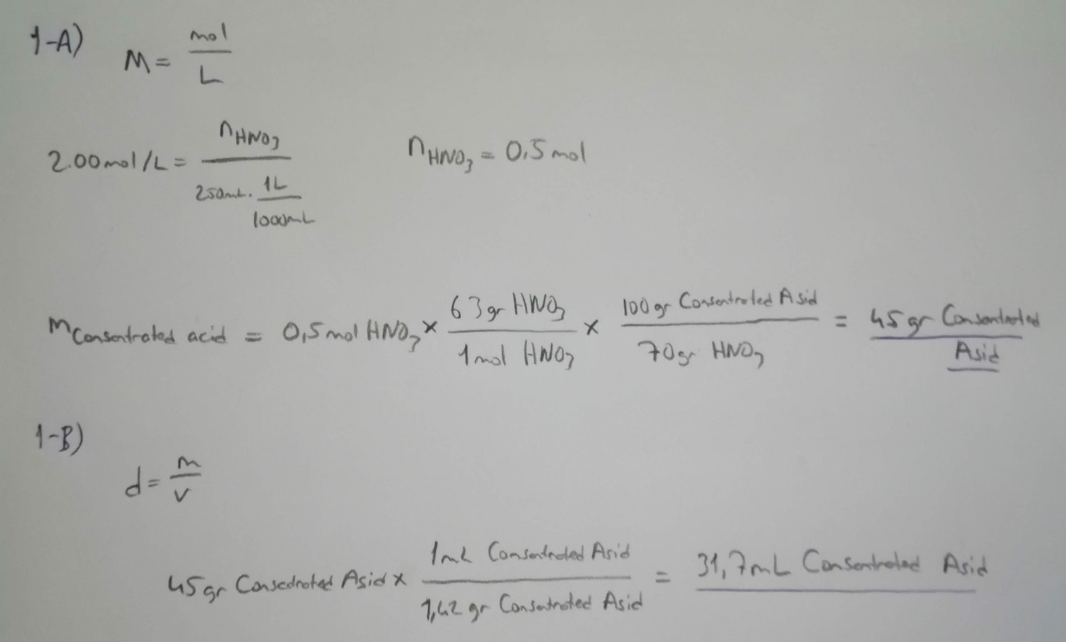

1-B) If the density of concentrated nitric acid solution is 1.42 g/ml, what volume should be used?

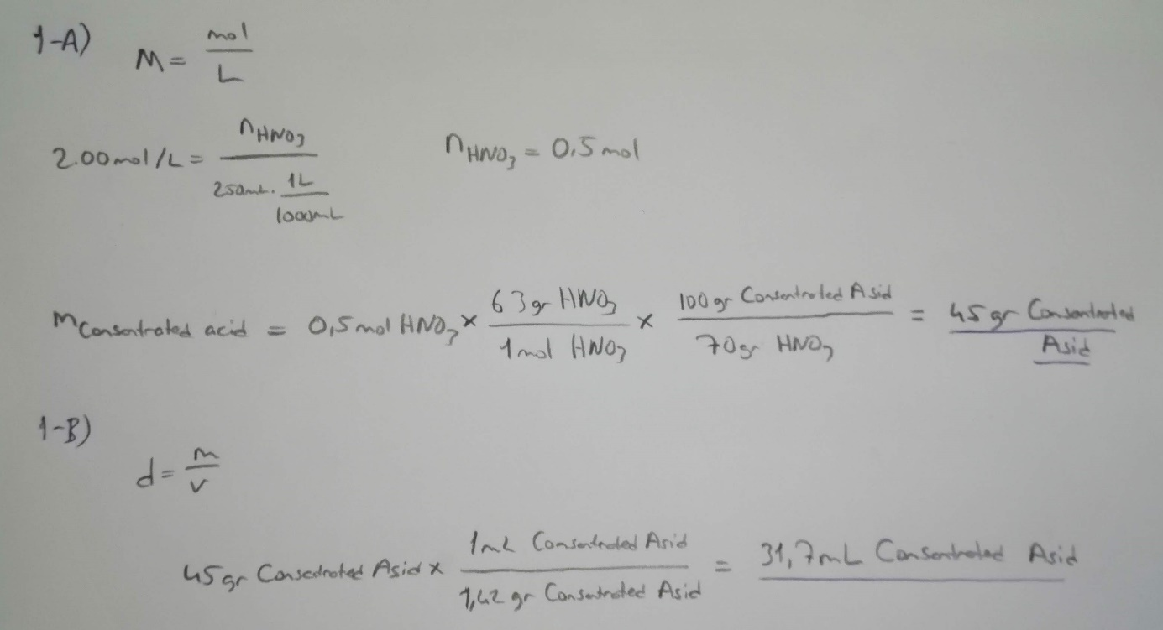

2) Why is water added first to the container in solutions prepared with acid?

A large amount of heat is released when strong acids are mixed with water. If you add water to acid, you form an extremely solution of acid initially, so much heat is released that the solution may boil very violently, splashing concentrated acid out of the container. If you add acid to water, the solution that forms is very dilute and the small amount of heat released is not enough to vaporize and spatter it so always add acid to water and never the reverse.

Referenced sources:

Websites:

<https://tr.wikipedia.org/>

<http://www.kimyaevi.org/>

<https://antoine.frostburg.edu/chem/senese/101/safety/faq/always-add-acid.shtml>

Books:

General Chemistry Principles and Modern Applications (10th Edition, Chapter 13).